STANDARD FORMAT OF “LEHENGA DESCRIPTION”


For Online Selling Products
Design Name: GEHNA-A
Product Colours NO.: A1
. 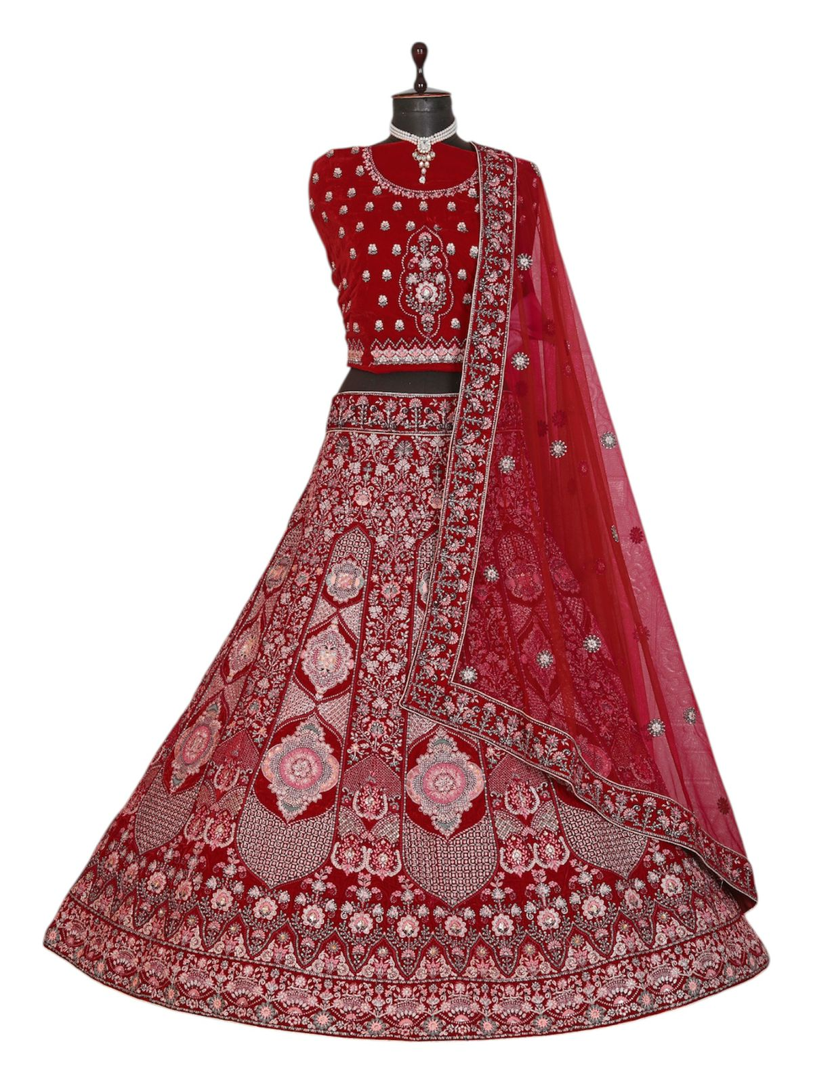
Particulars | Details
Lehenga Fabric | Velvet
Blouse Fabric | Velvet
Dupatta Fabric | Net
Work Type | Jari, Jarkan & Thread embroidery Work
Colour | Red
Pattern | Bridal Designer Lehenga
Stitching Type | Semi-Stitched (Can be customized up to 44")
Occasion | Wedding, Reception, Engagement & Festive Wear
Fit Type | Regular Fit
Care Instructions | Dry Clean Only
Package Contents | 1 Lehenga, 1 Blouse Piece, 1 Dupatta

KEY HIGHLIGHTS
- Crafted from luxurious velvet fabric for a rich and royal appearance
- Embellished with intricate Jari, Jarkan & thread embroidery
- Elegant net dupatta enhances the bridal look
- Perfect for weddings, receptions, and festive occasions
- Semi-stitched design supports easy customization
- Comfortable regular fit suitable for long event hours
- Blends traditional craftsmanship with modern bridal aesthetics

